Project Proposal

Name: Safeer A. Rana

Student Number: M00444202

Email: [SR1208@live.mdx.ac.uk](mailto:SR1208@live.mdx.ac.uk)

Course: Computer Science

Middlesex University

Supervisor: [R.Nagarajan@mdx.ac.uk](mailto:R.Nagarajan@mdx.ac.uk)

# Title: Mobile App development

# Introduction

The usage of smart phones and tablets is becoming a quickly growing industry in today’s society. The use of phone applications is rising further and further each time and the everyday use of them amongst individuals is enormous.

“By the end of 2012, Flurry estimates that the cumulative number of iOS and Android devices activated will surge past 1 billion.”

According to me research I found out that smartphone users between the age of 25 and 44 use highest amount of apps per month, on the other hand teenagers spend enormous time on them.

As more and more individuals are using phone applications the decision was made to develop an application for a football organizers and as well as the players and manger to use to find out the latest results and how each team progresses in the tournament. The app will be based under the category Utilities and it will be developed for (iOS/Android). It will allow the organizers to structure the tournament format as a Single Elimination style, League style or the World cup style put all those ideas onto this application which is like a virtual machine to see the upcoming games as well as what is require from each team to progress in the event.

This application is a tournament/league creation and management tool. It is idyllic for everyone who is involved in games/sports especially football. It can be used for both team events and individual challenges. This application enables the user to manage all tournaments in real-time, capturing all the data. It is ideal for competitive games or even social games. If planning tournament is part of your job, then this application will make your life much easier. This application will be useful to anyone with a competitive streak or players of any category.

The name of the Application will be FLT which stands for Football League Tournament. This Application will be intended at local football leagues for all ages groups e.g. Sunday league football, school leagues and so on.

Objective

The initial step is to collecting all essential research concerning football tournaments. This will be essential to associate and prepared precise to accomplish the project. The next stage is to develop an application which enables users to create their own tournaments. When accomplished, the application must be be tested for both usability and whether the features built-in was of any value to the tester. A critical assessment of the application will start after testing has been concluded.

Literature Review

Developments in mobile phones have enabled a widespread variety of applications to be developed that can be used by the users on the go. Developers occasionally overlook the element that users will want to engage with such devices while on the go. Small screen sizes, limited connectivity, high power consumption rates and limited input modalities are just some few concerns that occur when designing mobile phones for applications. Furthermore, these devices are designed to allow users to use them while mobile, the effect that the use of these devices has on the flexibility of the user is a serious influence to the accomplishment or disaster of the application.

Problem Description

Technology is only used on the top end in sports in order to make their takes at ease. The use of technology could do the same for all other smaller leagues in any sport.

The problem we are facing in today’s society is that only the top leagues have applications to allow them and their fans to see their upcoming fixtures, tables and results. This application will allow the minor leagues as well as made up leagues among friend and also in schools to keep a track on their leagues/tournaments.

Technology/Features

This Phone Application would contain a GUI, a database to keep track of information about the football fixtures and results, and league table to implement the various functions of the app. Furthermore, this could also contain an my team function to allow users to select his team, which instantly provide the user with the next upcoming match and the league table state of the selected team.

It would have an alert function to notify the user with up to date results.

This project is fascinating from a technical point of view as it involves iOS/Android phone app development, implementing a database to provide information on the upcoming fixtures, update daily results, developing a GUI, and ensuring that it is simple and easy to use.

The features the application could contain:

* Notifying the player/mangers on upcoming fixtures
* League Table
* Latest Results
* Team Stats
* Top Five Scorer
* Top Five Assists
* Adding/Removing Teams/Players

To accomplish this project the essential resources which are required to be able to program in the language java for android application, otherwise for an iOS application the language is called swift.

Challenges

The three major challenges to developing the product would be gathering and handling related data using a database and developing an Phone Application (iOS/Android) overall. Both of these are issues of not necessarily having learned the related concepts. These both threats can be diminished by ensuring by planning ahead in a timely enough manner to complete the product on schedule. The biggest challenge from all of them are two essential points in that approach is boosting the awareness of the app and keeping the app audience involved with it.

Resources Required

First of all a platform is required to programing in the specific language develop the app. To produce an Android application a software development kit is needed such as eclipse or android study and it will be programmed in java. These kits come with source code, developer tools and emulators for testing android applications. It also offers the user how to do videos, methodological reviews and guidelines on how to develop application.

On the other hand for an iOS application the platform is Xcode and the programming language is swift.

Evaluation / Outcome

The Key of testing of the application developed will be suitable in demand to identify if the user interface is idyllic for users. It will also specify if the material is constructed in a manner which suits the target audience.

Gantt chart

The Gantt chart demonstrates the numerus stages of proceeding to the accomplishment of this project, as well as the estimate time required to have the product which is the application to be completed and ready to launch.

**Gantt chart**

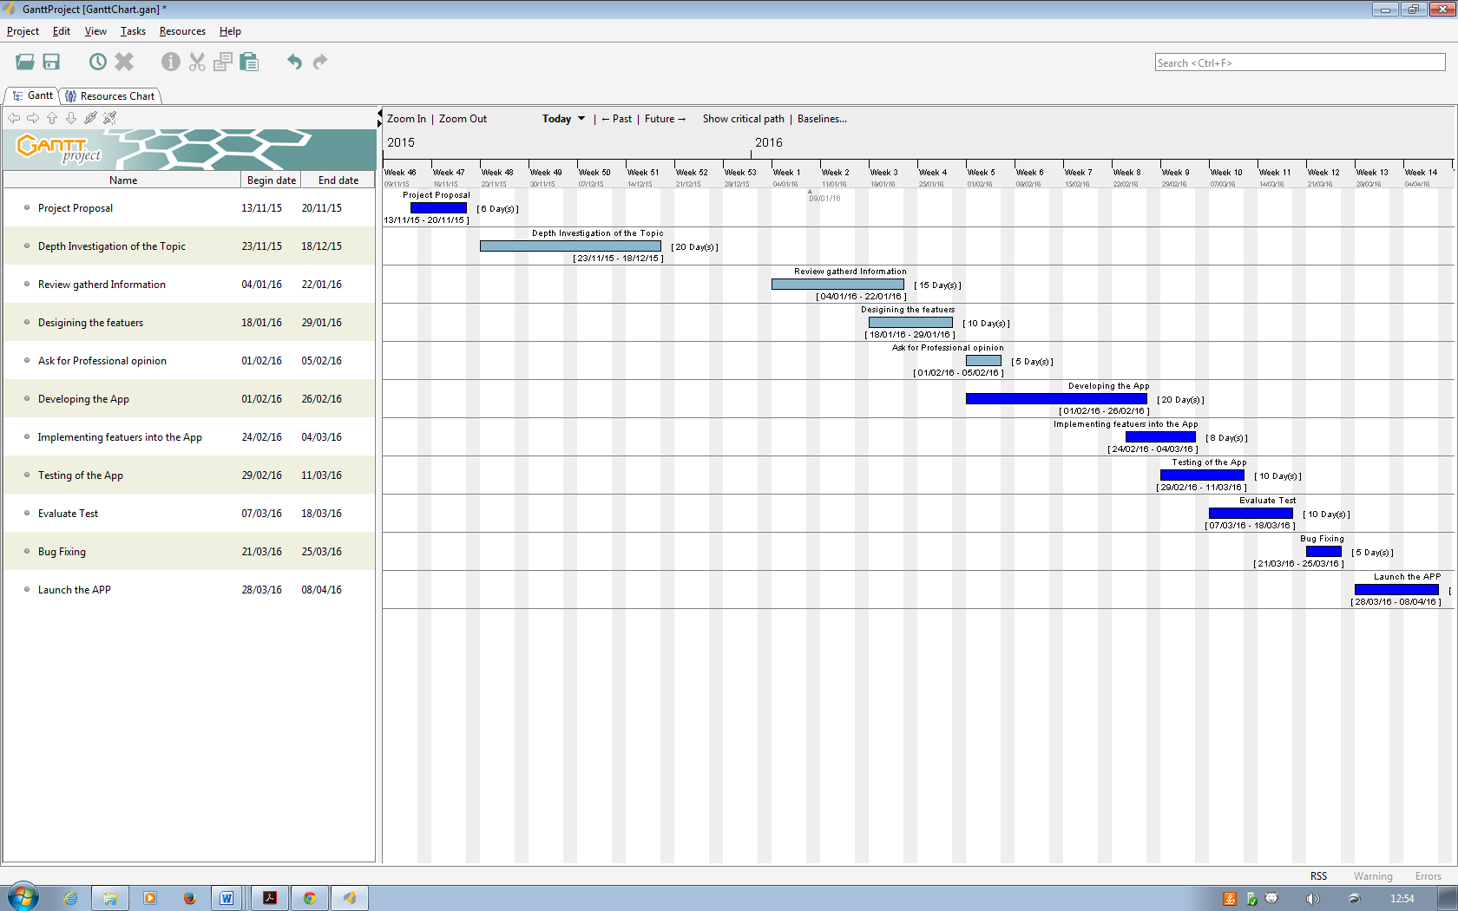

# Bibliography

#### Mobile App Usage Further Dominates Web, Spurred by Facebook

 ”By the end of 2012, Flurry estimates that the cumulative number of iOS and Android devices activated will surge past 1 billion.”

**In-text:** (Newark-French, 2015)

**Bibliography:** Newark-French, C. (2015). Mobile App Usage Further Dominates Web, Spurred by Facebook. [Online] Flurry Insights Blog. Available at: http://flurrymobile.tumblr.com/post/113376825595/mobile-app-usage-further-dominates-web-spurred-by [Accessed 1 Nov. 2015].

#### Smartphones: So Many Apps, So Much Time

**In-text:** (Smartphones: So Many Apps, 2015)

**Bibliography:** Smartphones: So Many Apps, S. (2015). Smartphones: So Many Apps, So Much Time. [Online] Nielsen.com. Available at: http://www.nielsen.com/us/en/insights/news/2014/smartphones-so-many-apps--so-much-time.html [Accessed 8 Nov. 2015].

#### Mobile App Marketing Insights: How Consumers Really Find and Use Your Apps

**In-text:** (Think with Google, 2015)

**Bibliography:** Think with Google, (2015). Mobile App Marketing Insights: How Consumers Really Find and Use Your Apps. [Online] Available at: https://www.thinkwithgoogle.com/articles/mobile-app-marketing-insights.html [Accessed 11 Nov. 2015].

* KNOW YOUR MOBILE

Sky Sports Live Football Score Centre

In-text: (Know Your Mobile, 2015)

Bibliography: Know Your Mobile, (2015). Sky Sports Live Football Score Centre. [Online] Available at: http://www.knowyourmobile.com/iphone-apps/6170/sky-sports-live-football-score-centre [Accessed 15 Nov. 2015].

* TURNER, J.

Nine Tools for Building Your Own Mobile App

In-text: (Turner)

Bibliography: Turner, Jeanne. 'Nine Tools For Building Your Own Mobile App'. Entrepreneur. N.P. [Online] Available at: http://www.entrepreneur.com/article/223177 [Accessed 18 Nov. 2015].

* NJUNJIC, I.

Development Techniques for Android Platform Mobile Device Application

**In-text:**(Njunjic, 2015)

**Bibliography:**Njunjic, I. (2015). *Development Techniques for Android Platform Mobile Device Application*. [Online] Commons.emich.edu. Available at: http://commons.emich.edu/cgi/viewcontent.cgi?article=1762&context=theses [Accessed 19 Nov. 2015].